2012 MESHACH SHIRAZ
The Story
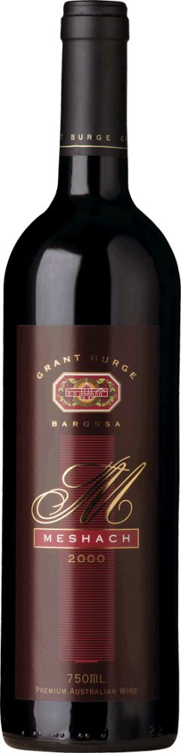
Meshach Burge was Grant Burge's Great Grandfather, and the man who began the Burge winemaking tradition. Aged 11, he came to the Barossa Valley from Hillcot in Wiltshire, England, with his family establishing a thriving viticultural wheat and sheep property near Lyndoch. In 1865, under the watchful eye of his father, Meshach began making the first wines in the Burge winemaking history. In tribute, our finest Shiraz bears his name.

The Fruit
The fruit for this iconic wine is predominantly handpicked from near century old vines from the famed Barossa Valley. The aged vines produce fruit with tremendous concentration and intensity that make Meshach powerful, yet beautifully balanced. The 2012 vintage provided exceptional conditions throughout the entire growing season. Good winter rains laid the foundation for a perfect spring, with mild and dry weather along with cool nights throughout vintage producing perfect ripening conditions. Grant and the winemaking team, think that the 2012 vintage is one of the best they have ever experienced.

The Winemaking
Winemaking with grapes from such old vines is kept very simple. After crushing, the grapes were inoculated with yeast and remained in the open fermenters for between 8 to 10 days under careful observation. The fermenters were gently pumped over 2-3 times a day to begin, with pump over times reduced as fermentation progressed to allow ideal extraction and maintain balance. On completion of fermentation on skins, the wines were gently basket pressed and allowed to settle for 24 hours. The wines were then transferred into a combination of French and American oak for 20 months maturation prior to bottling.

The Wine
The 2012 Meshach is a very complex wine, with red colour and purple hints. The aromas are a combination of plum, mulberries, dark chocolate, accompanied by cocoa powder and cinnamon cake. The palate is textural and richly flavoured, where dark chocolate, riper red berries are complemented by spices and earthly characters. The supple yet structured tannins create a powerful foundation to give the wine exceptional length and structure.
A truly distinctive Meshach Shiraz from an outstanding vintage, this wine will age gracefully over the next 15 years.

